

Table of Contents

Introduction 4

References 5

Course Contents 5

GitHub List Commits 5

What Even Is Webpack 6

Installing and Running Webpack and Webpack-CLI 8

Install Webpack 9

Webpack Default Configuration 12

Imports, Exports, & Webpack Modules 14

Configuring Webpack 16

Loaders, CSS, & SASS 19

Install CSS Loader 19

Install SCSS Loader 22

Cache Busting and Plugins 25

Splitting Dev & Production 29

Setup Webpack Dev Server 31

Html-loader, File-loader, & Clean-webpack 32

Multiple Entrypoints & Vendor.js 32

Extract CSS & Minify HTML/CSS/JS 32

# Introduction

**Webpack** is a powerful tool used in web development. Let’s dive into what it does:

1. **Module Bundler**:
   * **Webpack** is primarily a **module bundler**.
   * Its main purpose is to bundle JavaScript files (and other assets) for usage in a web browser.
   * Imagine it as a way to package all your code and assets into a single file or a few files that the browser can efficiently load.
   * It takes your project’s various modules (JavaScript files, CSS, images, etc.) and combines them into a single output file (or multiple files) that can be served to the browser.
2. **JavaScript Transformation and Optimization**:
   * Besides bundling, **Webpack** can also perform transformations on your code.
   * It can transpile modern JavaScript (ES6+) into older versions (ES5) using tools like Babel.
   * It optimizes your code by minifying it (removing unnecessary whitespace and renaming variables) to reduce file size.
   * This results in faster loading times for your web application.
3. **Configuration-Driven**:
   * **Webpack** uses a configuration file called webpack.config.js.
   * In this file, you define how your project should be bundled.
   * You specify entry points (where the bundling process starts), output paths, loaders (for handling different file types), and plugins (for additional tasks like code splitting or generating HTML files).
4. **Loaders and Plugins**:
   * **Loaders** allow **Webpack** to process different types of files (e.g., CSS, images, fonts) and convert them into valid modules.
   * **Plugins** enhance the bundling process by performing additional tasks.
   * For example, the **HTMLWebpackPlugin** generates an HTML file with the bundled JavaScript automatically injected.
5. **Code Splitting**:
   * **Webpack** supports code splitting, which means breaking your bundle into smaller chunks.
   * This is useful for optimizing performance by loading only the necessary parts of your application when needed (e.g., lazy loading routes).
6. **Development and Production Modes**:
   * **Webpack** has different modes: **development** and **production**.
   * In development mode, it provides features like source maps for easier debugging.
   * In production mode, it aggressively optimizes your code for better performance.
7. **Community and Documentation**:
   * The **Webpack** community is active, and there are plenty of plugins and loaders available.
   * The official documentation is comprehensive and provides guides, concepts, and examples to get you started.

In summary, **Webpack** is a versatile tool that simplifies managing your project’s assets, optimizes your code, and makes web development more efficient. If you’re new to it, check out the [Getting Started guide](https://webpack.js.org/guides/getting-started/) to explore its features!

# References

[Learn Webpack - Full Tutorial for Beginners](https://www.youtube.com/watch?v=MpGLUVbqoYQ&list=WL&index=3&t=2341s)

[Colt Steele's YouTube channel](https://www.youtube.com/channel/UCrqAGUPPMOdo0jfQ6grikZw)

[Colt Steele Github Code](https://github.com/Colt/webpack-demo-app)

Course Contents

⌨️ (0:00:00) What Even Is Webpack??

⌨️ (0:08:12) Installing and Running Webpack and Webpack-CLI

⌨️ (0:22:18) Imports, Exports, & Webpack Modules

⌨️ (0:29:58) Configuring Webpack

⌨️ (0:38:57) Loaders, CSS, & SASS

⌨️ (0:53:55) Cache Busting and Plugins

⌨️ (1:07:13) Splitting Dev & Production

⌨️ (1:17:13) Html-loader, File-loader, & Clean-webpack

⌨️ (1:28:17) Multiple Entrypoints & Vendor.js

⌨️ (1:34:45) Extract CSS & Minify HTML/CSS/JS

# GitHub List Commits

1. [Initial app code, no webpack](https://github.com/johncusey/webpack-demo-app/commit/b96a9dbce0d4abbf156612ccb23e4be74d6fd313) (What Even Is Webpack??)
2. [Break code into separate scripts, no webpack](https://github.com/johncusey/webpack-demo-app/commit/dd5492493336955c66c8960d4e50d76297199fbb) , [Installed webpack](https://github.com/johncusey/webpack-demo-app/commit/2400d188ea69f4a3bc6dd0f35e58f81dd8135e35) (Installing and Running Webpack and Webpack-CLI)
3. [Webpack now bundling all our app code](https://github.com/johncusey/webpack-demo-app/commit/2b11dd3624422ac8f57fced592dd824230c83693) (Imports, Exports, & Webpack Modules)
4. [Add webpack config file](https://github.com/johncusey/webpack-demo-app/commit/d13f75ab6c6c90e1e7232c2b03fde96b0dd8e6a5) (Configuring Webpack)
5. [Add first loaders to handle css](https://github.com/johncusey/webpack-demo-app/commit/65c2ac47091e301b3adc5b35a68c1870b16eafb7) , [Add Sass loader, override bootstrap colors](https://github.com/johncusey/webpack-demo-app/commit/21c9e3b62306c8b21b3277af5d5d931af5e9bd2a) (Loaders, CSS, & SASS)
6. [Cache busting and HtmlWebpackPlugin](https://github.com/johncusey/webpack-demo-app/commit/c932911657e0a7beb9c03f604eaafa7e954d51ba) (Cache Busting and Plugins)
7. [Add prod and dev configs, dev-server](https://github.com/johncusey/webpack-demo-app/commit/eb66c0dc93141080f5b1abb335ec998a1e91d72e) (Splitting Dev & Production)
8. [Add html-loader, file-loader, and clean-webpack-plugin](https://github.com/johncusey/webpack-demo-app/commit/947290016d91f0cc2298faa86bedb1ee2180c276) ( Html-loader, File-loader, & Clean-webpack)
9. [Add entrypoint for vendor js file, add bootstrap js](https://github.com/johncusey/webpack-demo-app/commit/34e7d30aefa510e7f10dc8b496b88eab8e4e9ce0) (Multiple Entrypoints & Vendor.js)
10. [Minify JS, CSS, and HTML in production](https://github.com/johncusey/webpack-demo-app/commit/991f703d058ece361b83180ada43dc5f61b40984) (Extract CSS & Minify HTML/CSS/JS)

# What Even Is Webpack

Webpack Official Website:

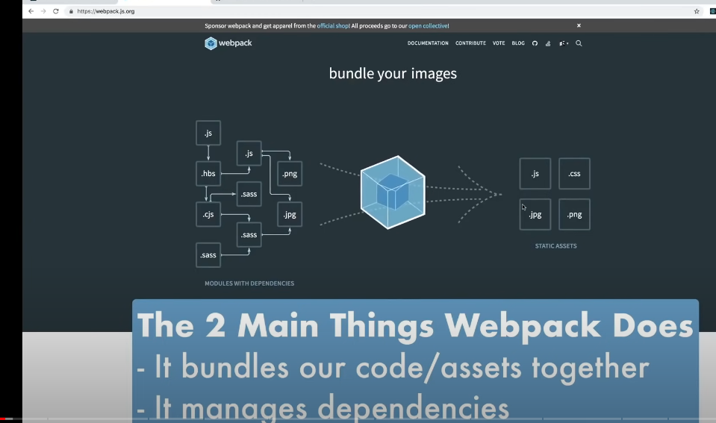

Webpack Official GitHub Website:

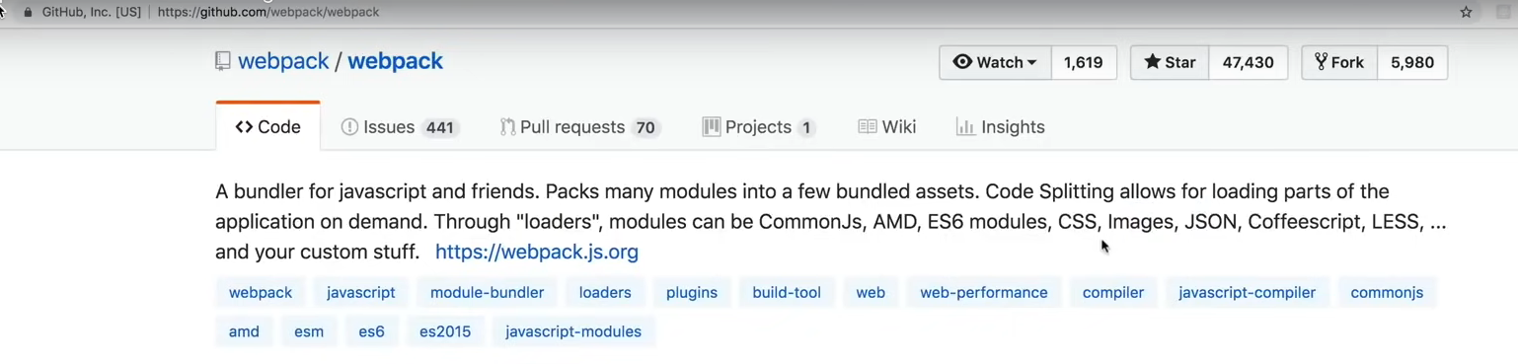

The file structure webpack generates.

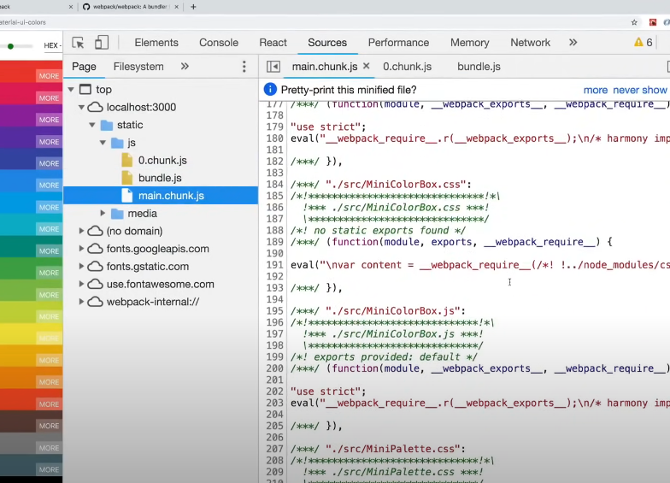

Command for building a React Application.

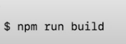

The file structure Webpack generates

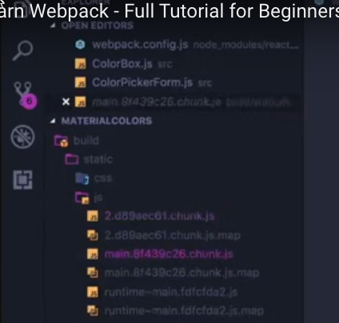

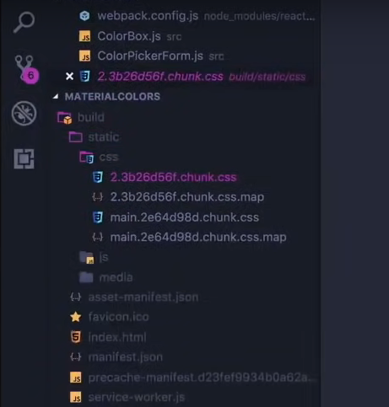

# Installing and Running Webpack and Webpack-CLI

Example code base used by Colt Steele

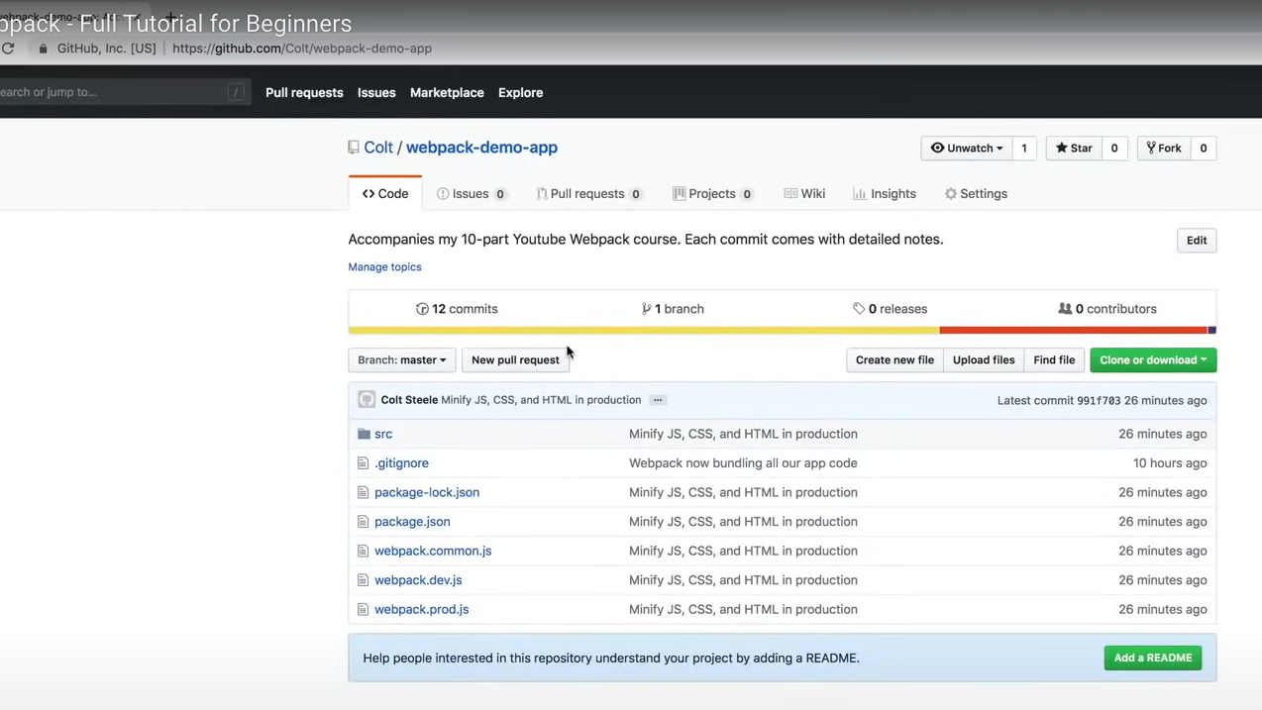

The file structure of the starter project.

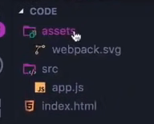

Screen shot the the appliction

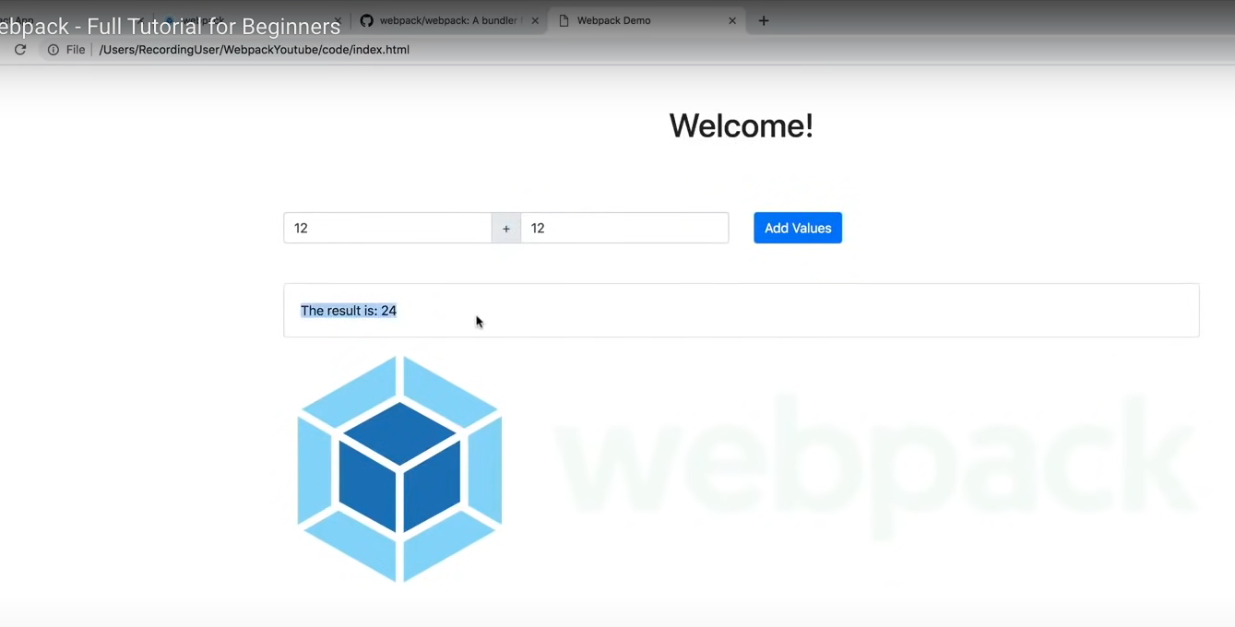

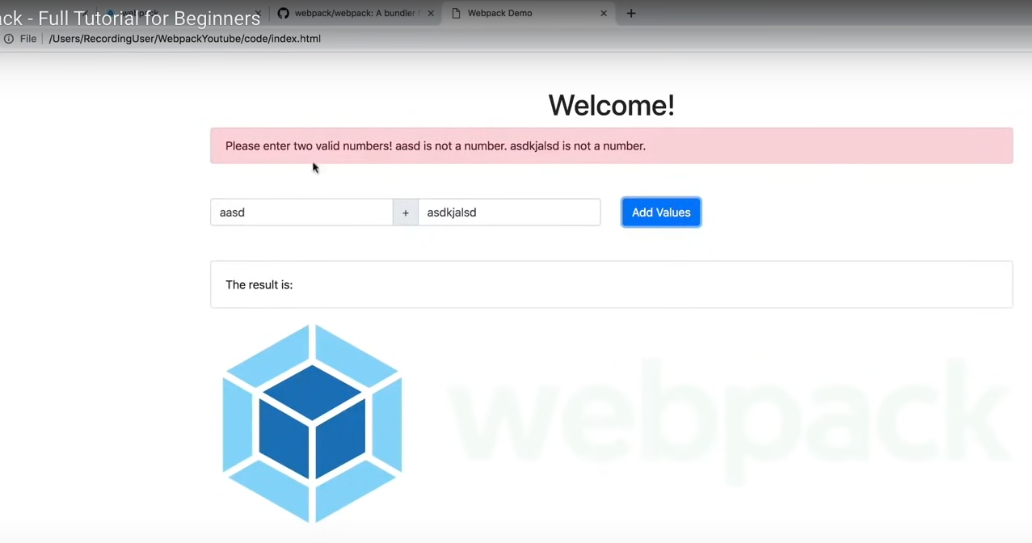

The coding structure after refactoring the code into many files for Webpack to bundle.

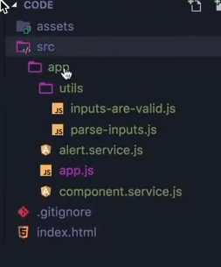

You have to include all the JavaScript files in script tags. If you use Webpack you can eliminate all these script tags.

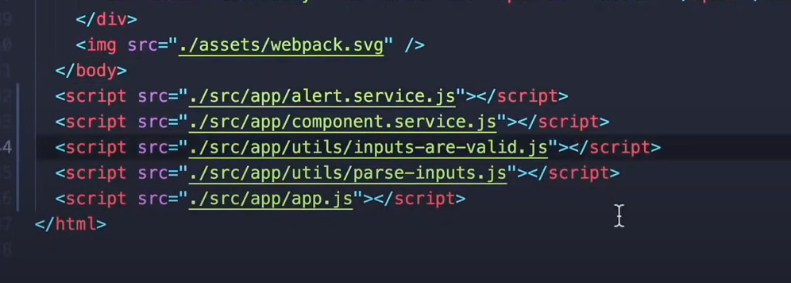

## Install Webpack

1) Install Package Json

Install package json file run the following command. The package.json file is a crucial part of Node.js projects. Here’s what it does:

1. **Metadata and Descriptive Information**:
   * It’s a **JSON file** residing in the root directory of your project.
   * Contains both **human-readable metadata** (like project name and description) and **functional metadata** (such as package version number).
   * Helps people discover your package by providing a **description** and **keywords**.
   * [Specifies the **project homepage URL** and the **issue tracker URL** where users can report issues1](https://docs.npmjs.com/cli/v6/configuring-npm/package-json/)[2](https://heynode.com/tutorial/what-packagejson/).
2. **Dependency Management**:
   * Lists the **dependencies** required by your application.
   * When you run npm install, it installs the dependencies specified in this file.
   * Helps manage versions and ensures consistent behavior across different environments.
3. **Versioning**:
   * The **name** and **version** fields together form a unique identifier for your package.
   * Changes to the package should correspond to changes in the version.
   * If you plan to publish your package, these fields are **required**.
   * [If not publishing, they are **optional**1](https://docs.npmjs.com/cli/v6/configuring-npm/package-json/).
4. **License Information**:
   * Specify a **license** for your package (e.g., BSD-3-Clause or MIT).
   * Helps users understand how they can use your package.
   * [Use SPDX license identifiers or custom strings1](https://docs.npmjs.com/cli/v6/configuring-npm/package-json/).
5. **Scripts and Commands**:
   * Define custom **scripts** (e.g., build, test, start) that can be executed using npm run.
   * Makes it easy to automate common tasks during development.
6. **Other Details**:
   * You can include a **file** named <filename> at the top level of the package.
   * [Deprecated styles like license objects are now replaced with SPDX expressions1](https://docs.npmjs.com/cli/v6/configuring-npm/package-json/)[3](https://nodesource.com/blog/the-basics-of-package-json/).

In summary, package.json is your project’s **manifest**, containing essential information for Node.js, npm, and JavaScript development.

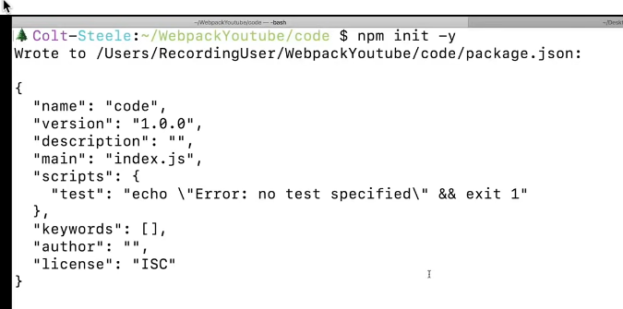

**$ npm init -y**

2) Install Webpack and Webpack CLI

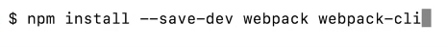

**npm install --save-dev webpack webpack-cli**

3) Changing script in Package Json

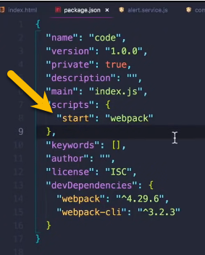

# Webpack Default Configuration

Have Webpack bundle the project by using the script in the Package Json. The **“scripts”** property allows you to define custom commands that can be executed.



If you see the following error you need ***index.js*** file in the ***src folder***.



Solution:

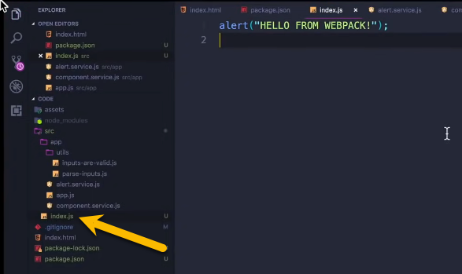

After run Webpack you get the following message. The ***index.js*** is the entry point

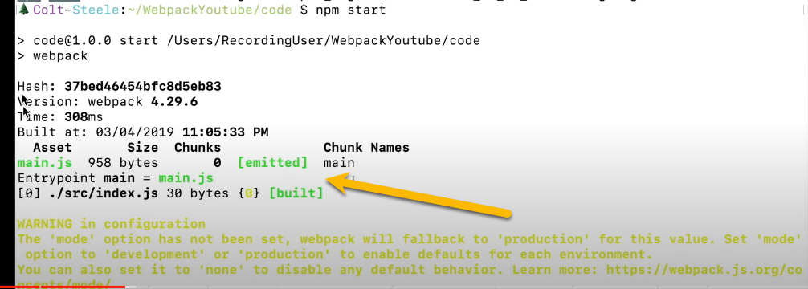

Webpack create the **dist** folder with ***main.js***

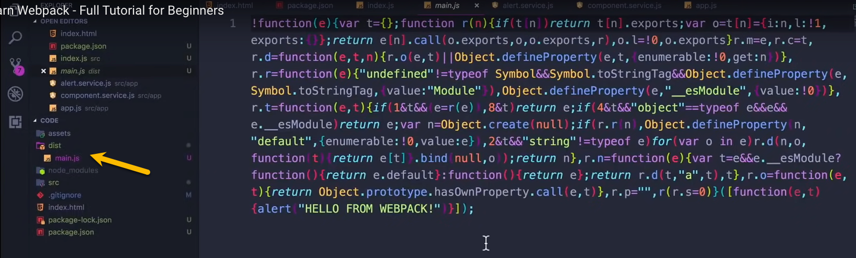

You need to added ***main.js*** to your ***index.html*** file.

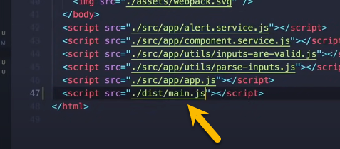

Now you can see calling the ***index.js*** entry point file.

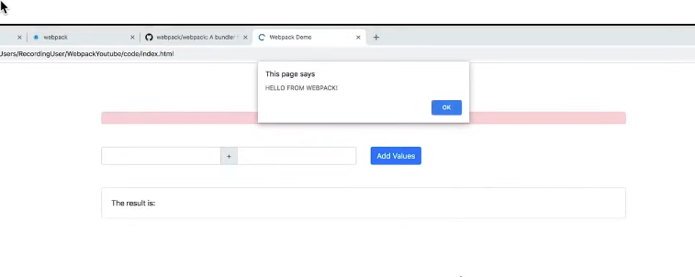

We are going to put all our ***JavaScript code*** in the ***Index.js*** file.

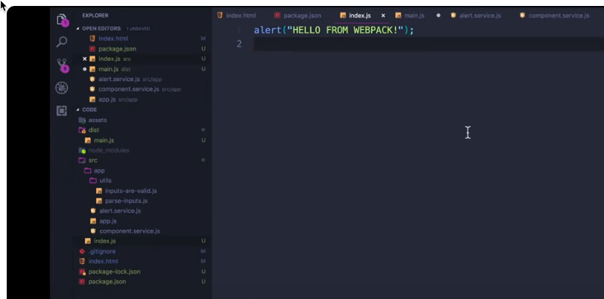

# Imports, Exports, & Webpack Modules

All the files you have to add export and import:

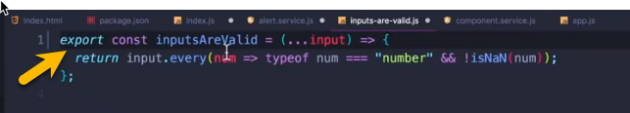

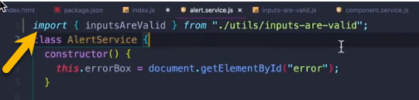

Most important in your ***index.js*** which is your entry point to your application most put the run function.

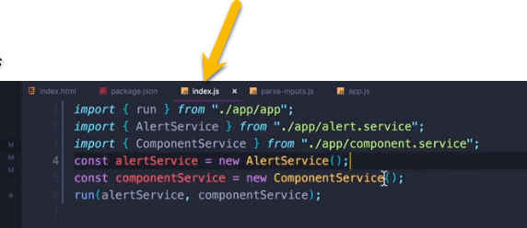

In the index.html you need just the entry point file which is located in the dist folder.

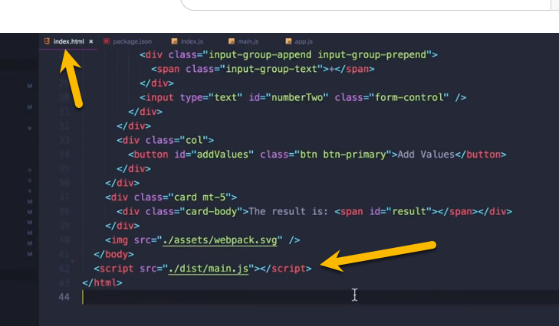

Now you have to start Webpack:



# Configuring Webpack

**Webpack** is a powerful build tool that helps bundle and optimize your JavaScript, CSS, and other assets for web applications. It allows you to manage dependencies, transpile code, and create production-ready bundles. Let’s dive into some key points about configuring Webpack:

1. **Out-of-the-Box Defaults**:
   * By default, Webpack assumes that your project’s entry point is src/index.js and generates a minified and optimized bundle in dist/main.js for production.
   * You don’t need a configuration file initially, but most projects eventually require customizations.
2. **Creating a Configuration File**:
   * To extend Webpack’s functionality, create a webpack.config.js file in your project’s root folder.
   * This configuration file allows you to specify various options and features.
   * You can find all available configuration options in the [official documentation](https://webpack.js.org/configuration/).
3. **Customizing Your Configuration**:
   * If you want to use a different configuration file based on specific situations, you can specify it via the command line using the --config flag.
   * For example, in your package.json:

**JSON**

"scripts": {

"build": "webpack --config prod.config.js"

}

* + To set up a new Webpack project, consider using webpack-cli’s init command:

***npx webpack init***

* + This command will guide you through creating a configuration file based on your project requirements.

1. **Webpack Config Basics**:
   * A Webpack config is a JavaScript object that configures various options.
   * You can define loaders, plugins, entry points, output paths, and more.
   * Most projects use a top-level webpack.config.js file, but you can also pass the config as a parameter to Webpack’s Node.js API.

Remember that Webpack’s configuration can be overwhelming due to its extensive options, but tools like webpack-cli can simplify the process. Explore the [Getting Started guide](https://webpack.js.org/guides/getting-started/) to learn more!

**Webpack Config Basics**:

* A Webpack config is a JavaScript object that configures various options.
* Common options include:
  + entry: Specifies the entry point(s) for your application.
  + output: Defines where Webpack should put the bundled files.
  + loaders: Handles different file types (e.g., transpiling JavaScript with Babel).
  + plugins: Enhances Webpack’s functionality (e.g., minification, code splitting).

[Webpack Configuration Definations](https://webpack.js.org/configuration/)

The webpack.config.js file plays a crucial role in configuring **Webpack**, allowing you to customize its behavior according to your project’s needs. [You’ll typically find this file in the root folder of your project, alongside the package.json file1](https://webpack.js.org/configuration/)[2](https://desarrolloweb.com/articulos/configuracion-webpack-config-js.html).

Here are some key points about the webpack.config.js file:

1. [Default Behavior: By default, Webpack assumes that your project’s entry point is src/index.js and generates the output in dist/main.js, which is minified and optimized for production1](https://webpack.js.org/configuration/).
2. **Creating Your Own Configuration**: To extend Webpack’s functionality, you can create a webpack.config.js file in your project’s root folder. Webpack will automatically use it when building your project. [All available configuration options are specified in this file1](https://webpack.js.org/configuration/).
3. **Example Initialization**:
   1. To quickly generate a Webpack configuration, you can use the following command:
   2. npx webpack init
   3. This command will prompt you to install @webpack-cli/generators if it’s not already installed. It will also ask you a series of questions to tailor the configuration to your needs. For example:
      1. Which JavaScript solution do you want to use? (ES6)
      2. Do you want to use webpack-dev-server? (Yes)
      3. Do you want to simplify HTML file creation for your bundle? (Yes)
      4. Do you want to add PWA support? (No)
      5. Which CSS solution do you want to use? (CSS only)
      6. Will you be using PostCSS in your project? (Yes)
      7. Do you want to extract CSS only for production? (Yes)
      8. Do you want to install prettier for formatting the generated configuration? (Yes)
      9. [Pick a package manager (e.g., pnpm)](https://webpack.js.org/configuration/)[1](https://webpack.js.org/configuration/).
4. [**Remember**: Webpack applies configuration defaults after plugin defaults, so you can fine-tune your setup as needed1](https://webpack.js.org/configuration/).

Feel free to explore the available options and features in your webpack.config.js file to optimize your Webpack build process! 😊

**Important !** Tell Webpack which file to uses. You can set the value in your package.json file.

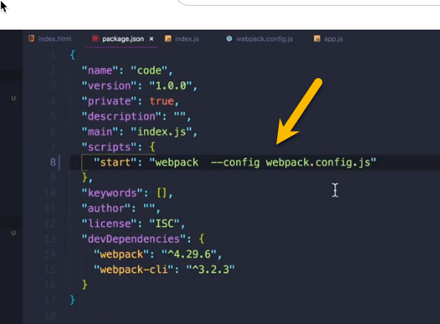

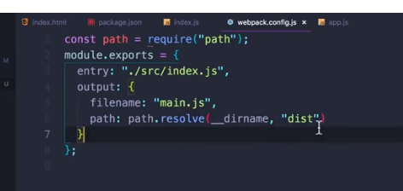

In the webpack.config.js setting the devtool property to get rid of the eval in JavaScript code the bundle files.

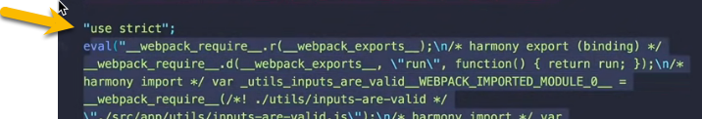

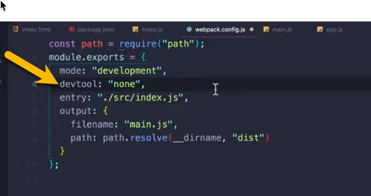

You can see that your code is in the Webpack bundle files unchanged.

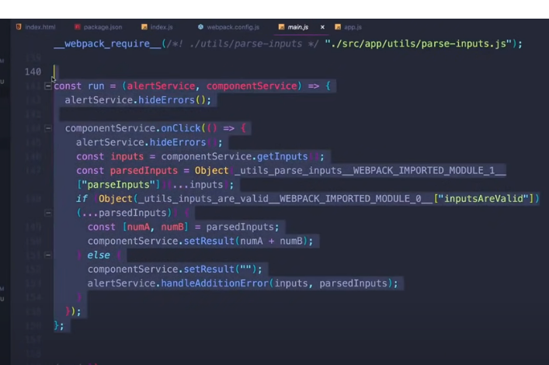

# Loaders, CSS, & SASS

These instructor are NOT correct

## Install CSS Loader

[Webpack Loaders Official](https://webpack.js.org/loaders/)

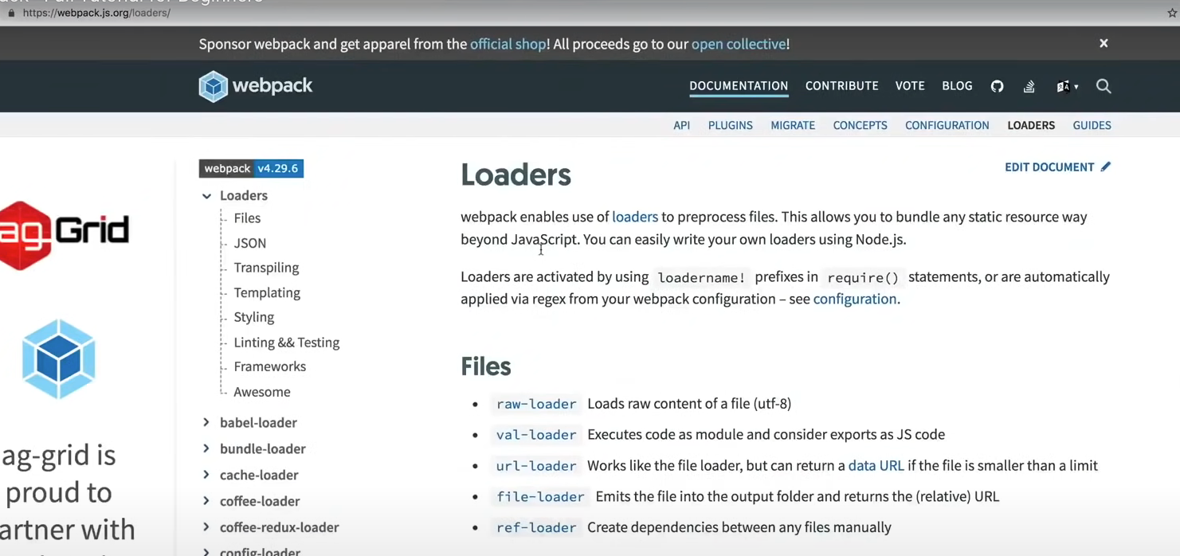

This example show how to bundle css file with Webpack. In the example code you need to create main.css file to be bundled.

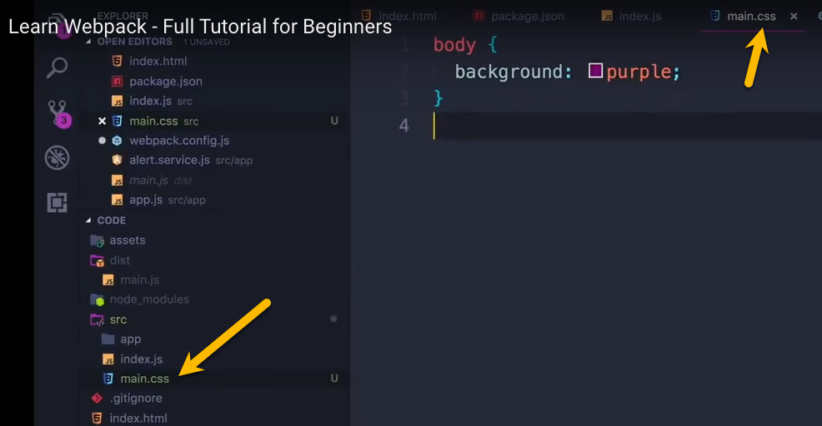

The instructions for bundle css are on the following Webpage:

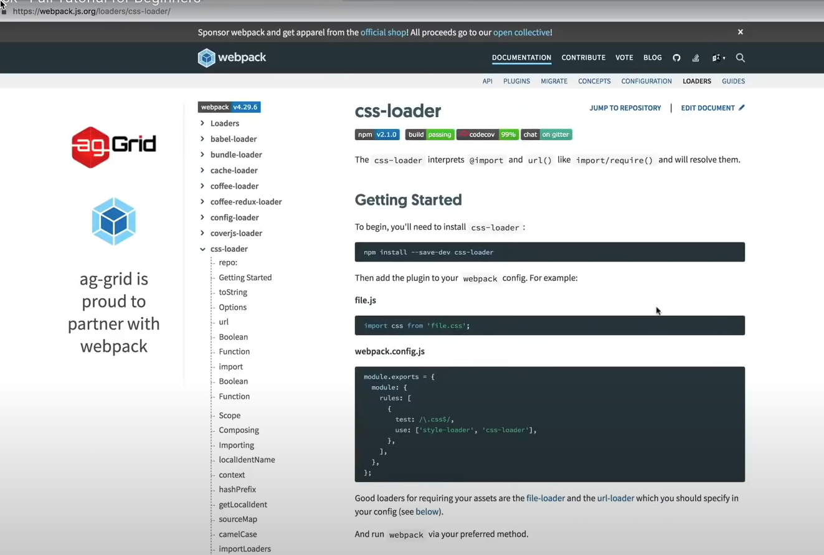

Install the loaders:



Update the Webpack Configuration file:

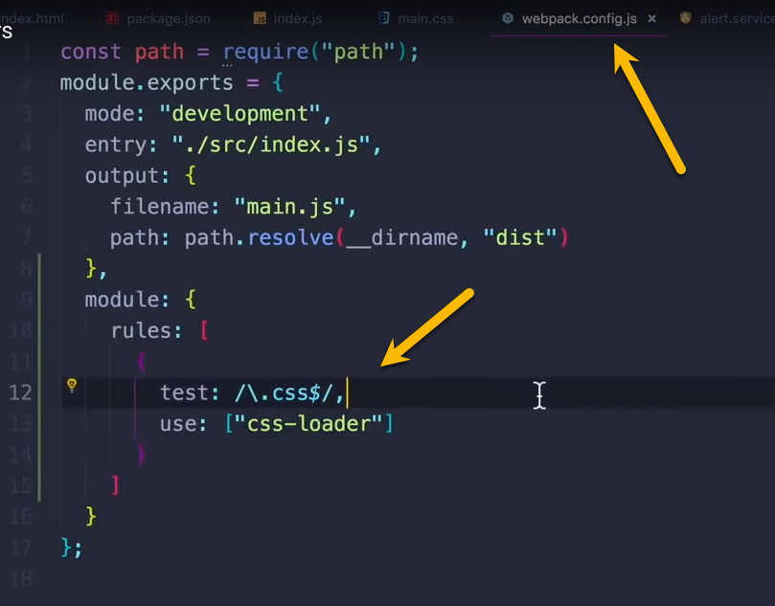

Including main.css in the index.js file.

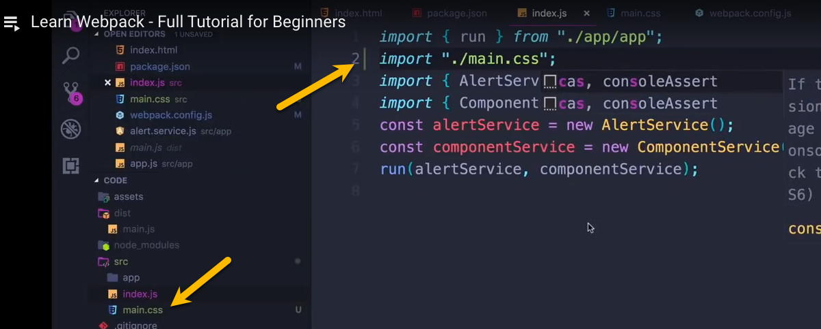

## Install SCSS Loader

First install boostrap locally. We are going to overwrite some of the bootstrap sytle with SCSS.



Change the file name from main.css to main.scss in the project.

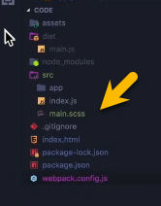

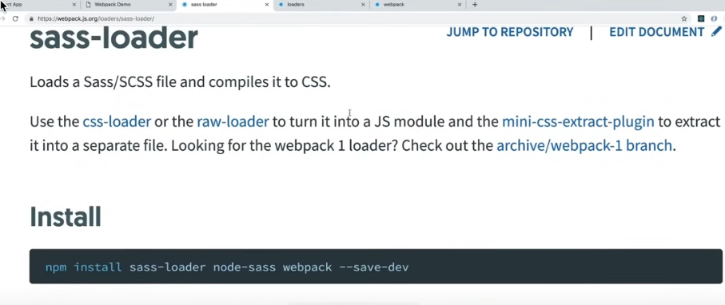



To overwrite the bootstrap most incude in the main.scss file.

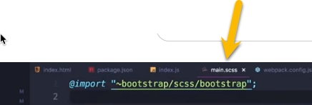

Must change the Webpack configuration file.

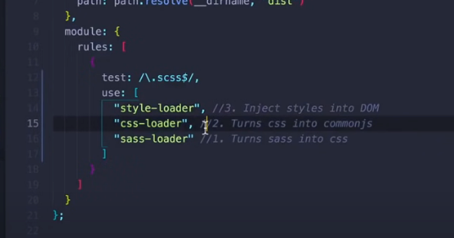

Do not forget to change from main.css to main.scss in the index.js.

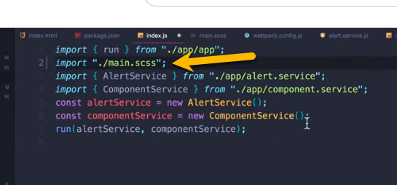

Overwriting the **button** and **message colors** in the main.scss file.

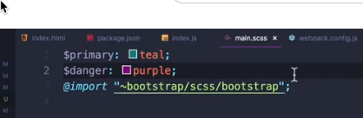

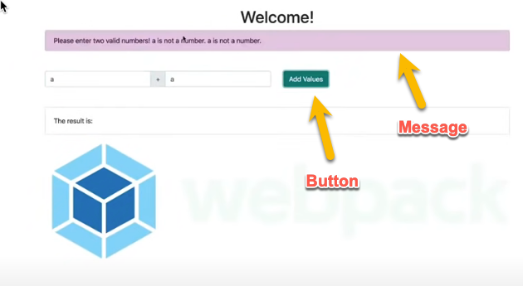

# Cache Busting and Plugins

Stop the browser from cache resources. You can see the resources in Dev Tools under the **Network tab**.

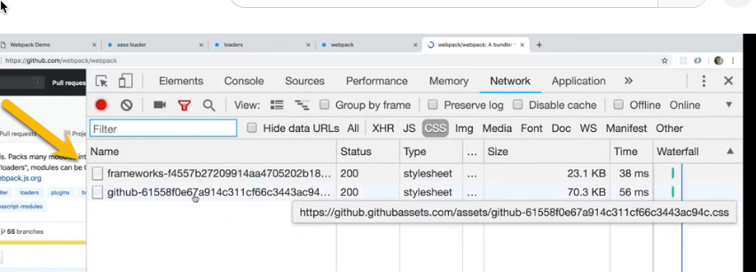

After fresh the broswer you with see the the Network Tab next to cache resource you will see message (from disk cache)

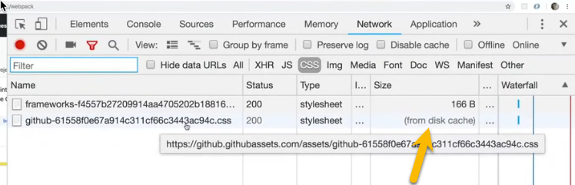

In the webpack.config.js change the filename property.

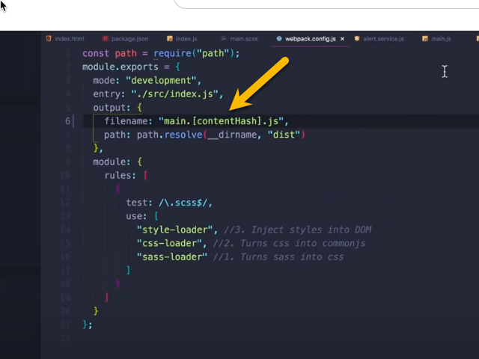

You can see it works by the change file name on the main.js.

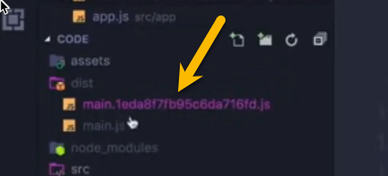

You are using main.js in the index.html file. You can uses the Webpack to include the main.1eda87b95c6da716fd.js (main file with generated hash) in the index.html file. Do not include <script src="./dist/main.js"></script> so Webpack will generate the script tag.

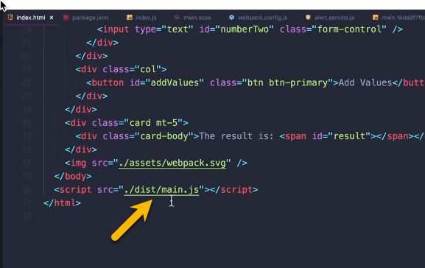

We do this will plugs.

[Webpack Plugins Official](https://webpack.js.org/plugins/)

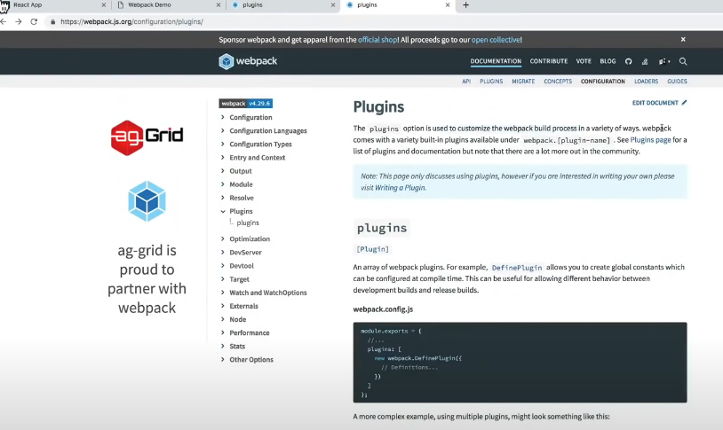

Add the plugins. We can have templete file were we can the webpage layout tags.

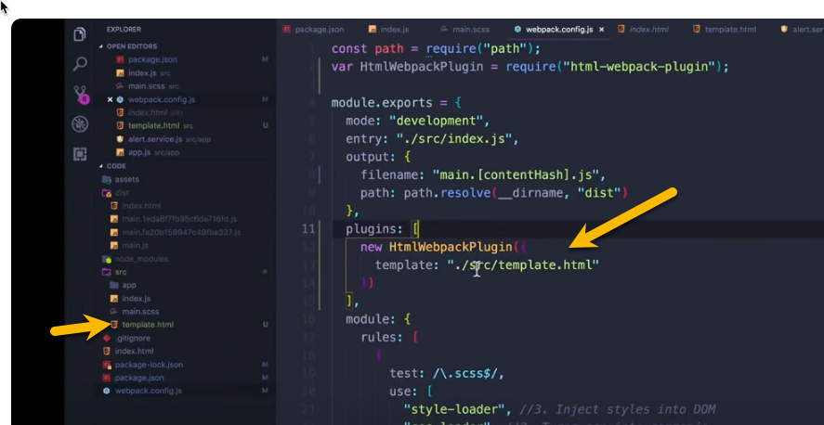

template.html in the src folder.

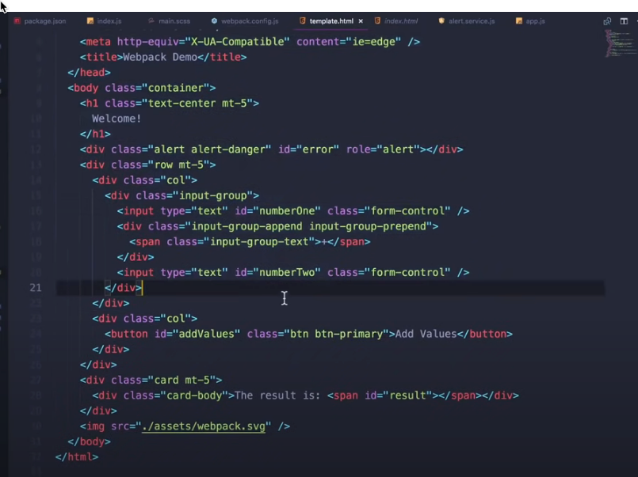

# Splitting Dev & Production

Split the webpack configurate file into many files.

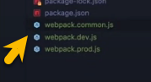

This plugin is used to merge to webpack configuration files together.

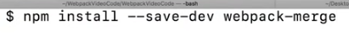

Putting merge object to do all the merge work.

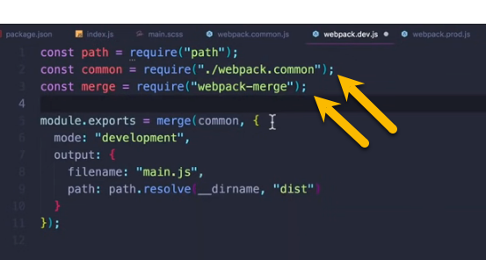

Change the script in the package.json file for the different configuare files.

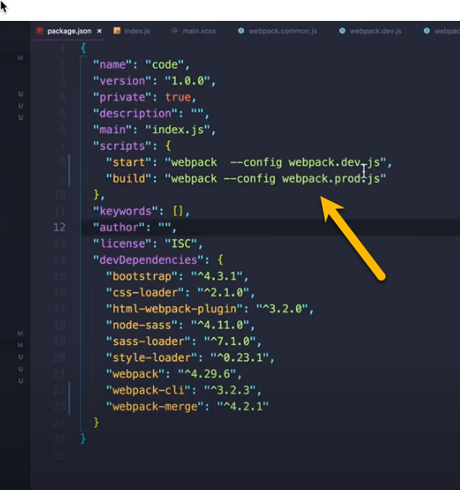

## Setup Webpack Dev Server



**$ npm install --save-dev webpack-dev-server**

The --open option will open the broswer with the running application.

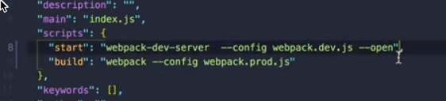

# Html-loader, File-loader, & Clean-webpack

Move to assets into the src folder.

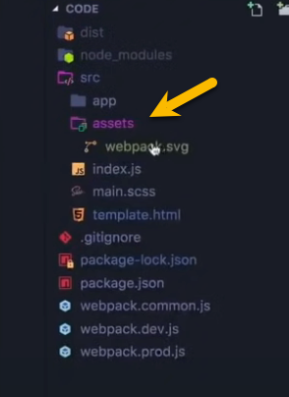

Need two loads html-loader and file-loader.

## html-loader

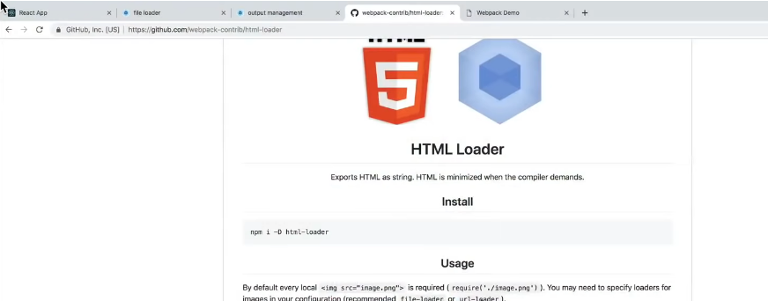

Install html-loader



Change the Webpage configuare file

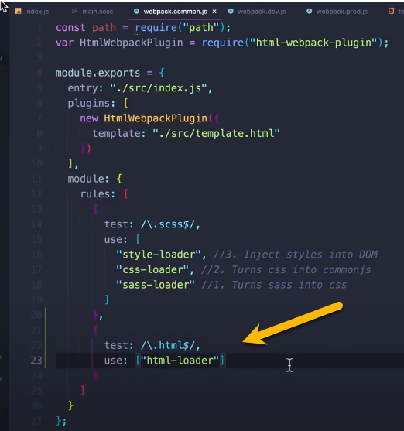

## file-loader

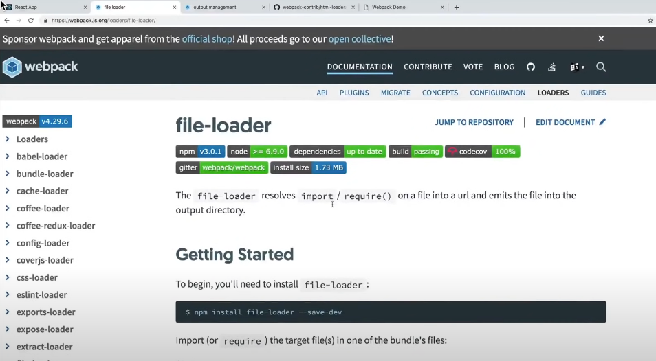

Install file-loader

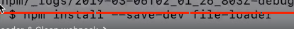

**$ npm install --save-dev file-loader**

Change the Webpack configure file

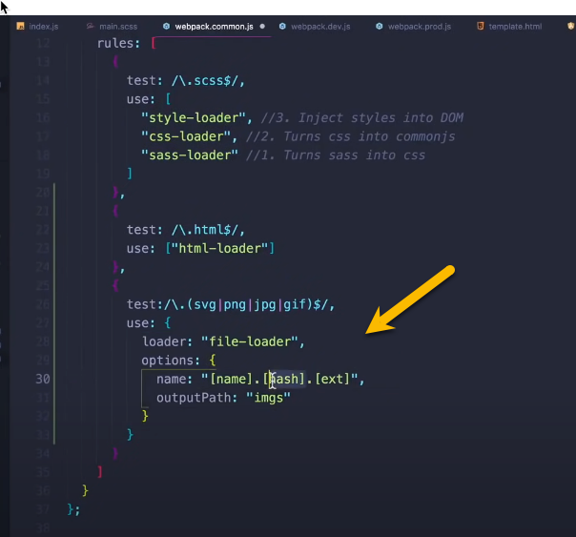

The Webpage generated index.html file in the dist folder.

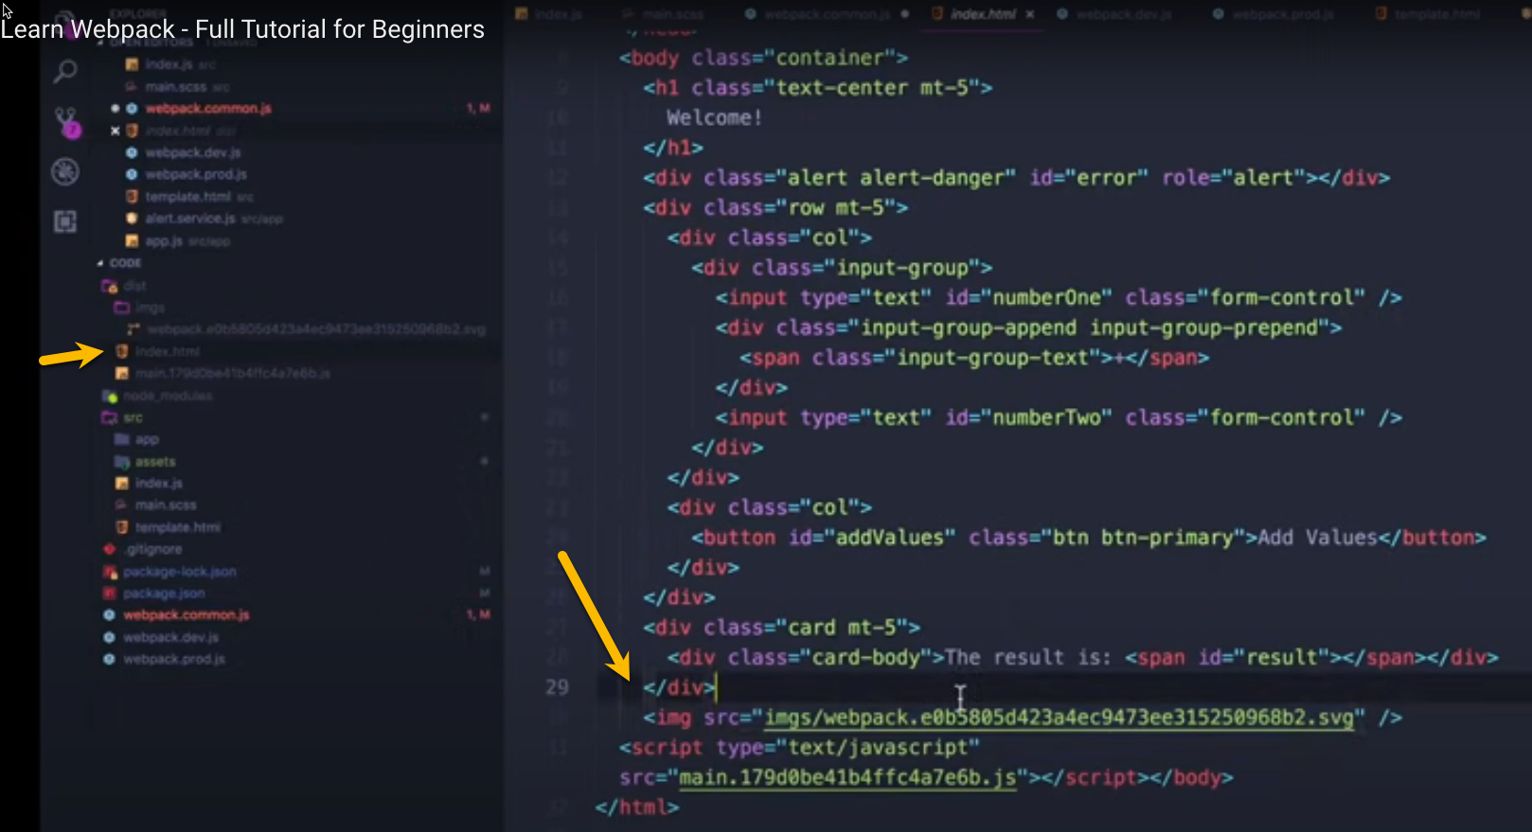

## clean-webpack-plugin

Remove for production the dist folder each time we change the code.



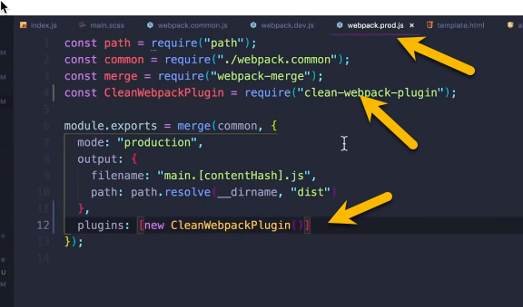

To run production build

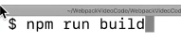

# Multiple Entrypoints & Vendor.js

## Create Vender

Create new file name vender.js

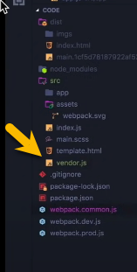

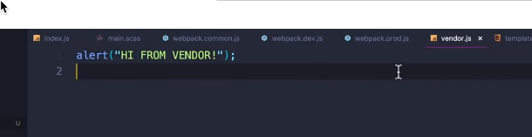

## Setup Vender

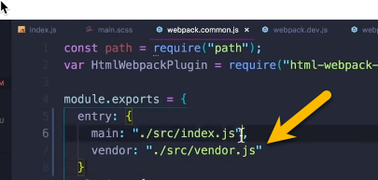

Change child Webpack configuare file with [name] so Webpack will take entry main (./scr/index.js) and vender (./scr.vendor.js) substitute into [name]

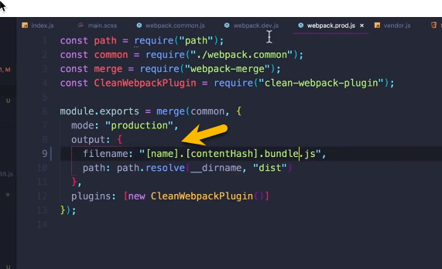

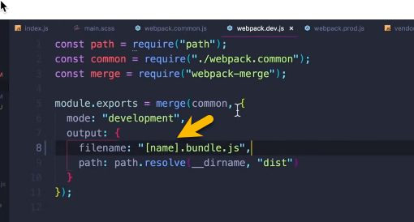

Build DEV enviroment

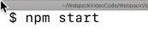

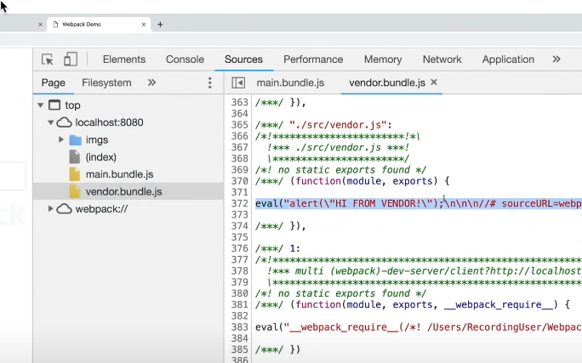

Build PROD enviroment

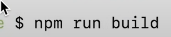

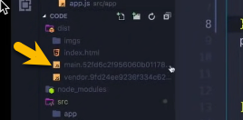

See new vender file in your index.html

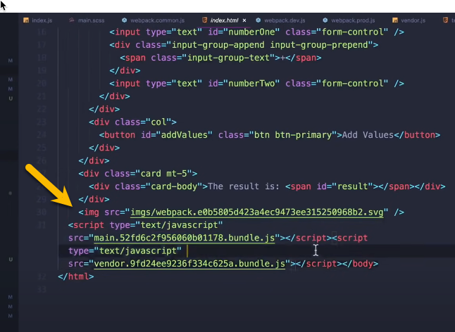

## Setup bootstrap

Install Jquery and Popper



**$ npm install --save-dev jquery popper.js**

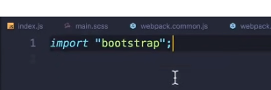

# Extract CSS & Minify HTML/CSS/JS

## mini-css-extract-plugin

The css loads last so see a flash unstyle page for a second before style sheet loads.

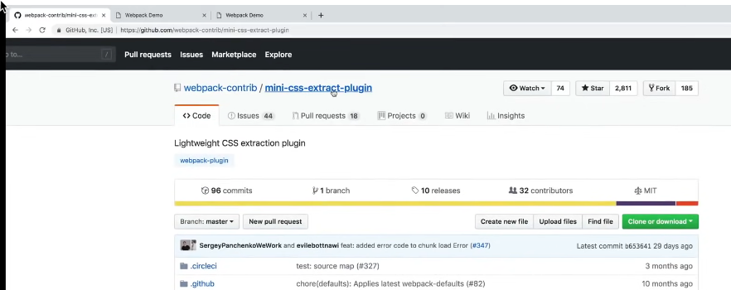

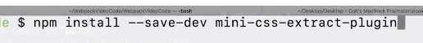

Add the plugin to Webpack configurate webpack.prod.js for PROD environment

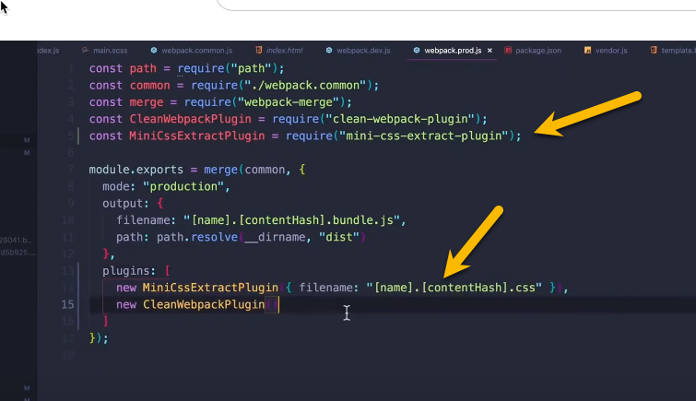

Move the following code from webpack.common.js to webpack.dev.js

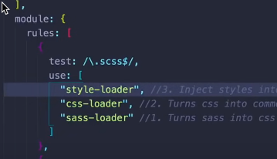

In webpack.prod.js add the following code.

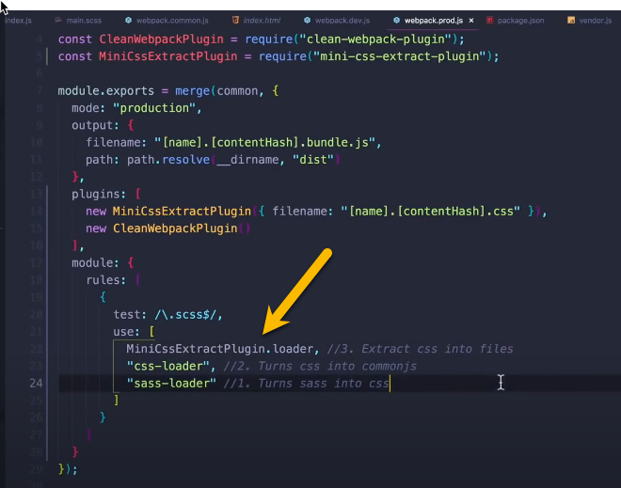

Build PROD environment



After the build you get link tag in the head

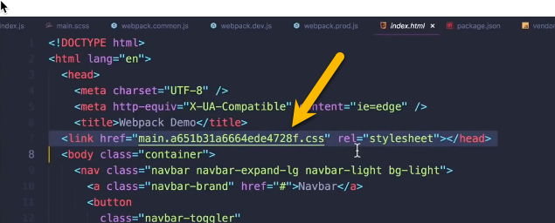

## optimize-css-assests-webpack-plugin

